carl de witt cos 214 Prac 2

Task1

1.3) Template method

Task 2

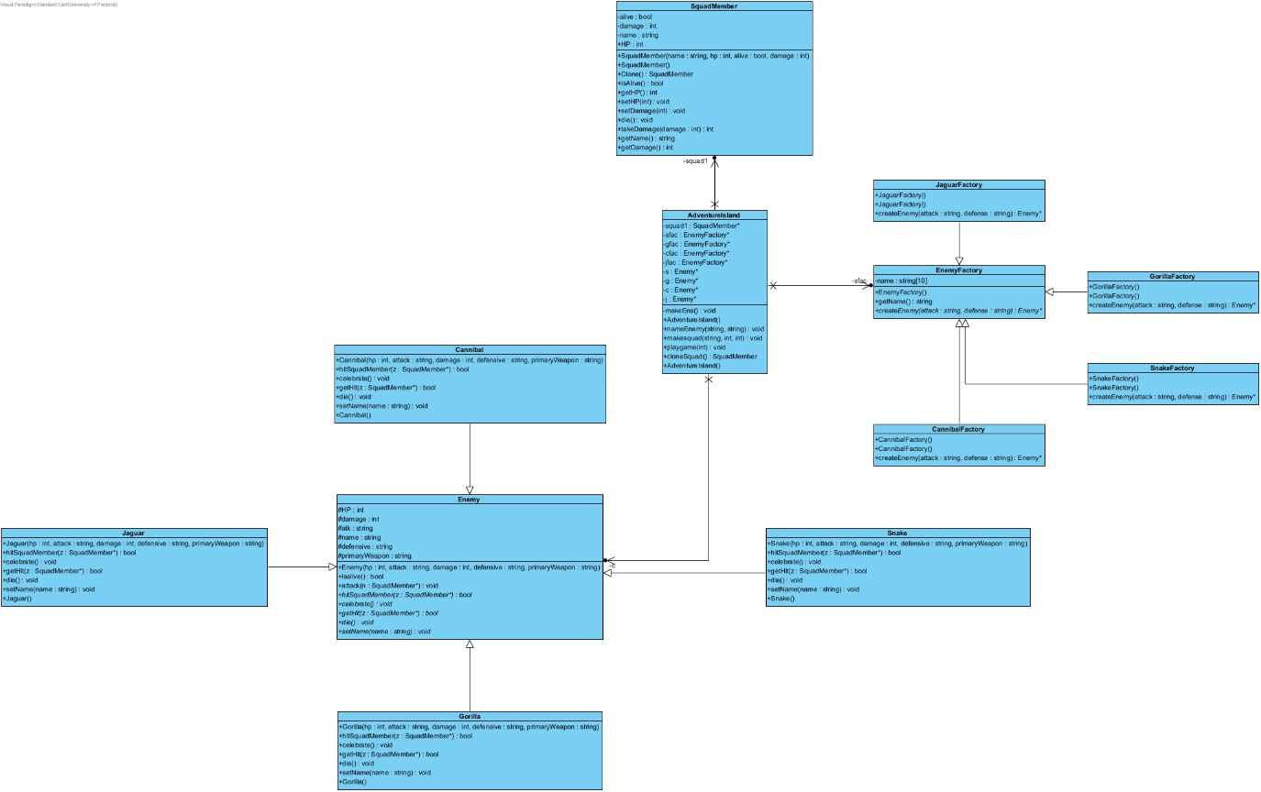2.4)

2.5)

2.6)

Factory:

* EnemyFacotry

Concrete factory:

* CannibalFactory
* GorillaFactory
* SnakeFactory
* JaguarFactory

Product:

* Enemy

Concrete Product:

* Cannibal
* Jaguar
* Snake
* Jaguar

2.7) Factory method